Last week, we explored our tendency to idolize Marriage. We think of ourselves as half-persons, looking for that soulmate who will complete us. But Marriage and Romance can’t make us whole. If we rely on Romance to fulfill us, to complete us, to make us whole, we’ll be let down over and over.

In our quest to find the One, one of the all-time most important factors is compatibility (it's part of that "missing puzzle piece" mindset we talked about last week). True Love, we think, is finding that person with whom we "click", a person who either shares all our same interests or complements us in such a way that when people meet us, they think, Wow, what a great match!

Compatibility is so all-important that online dating base their entire business models on it. eHarmony promises they'll "help you find the most promising matches. People whose goals, values and personality traits most complement you... Which means you've already got a great foundation and a head start." Other sites all have you list your likes and dislikes, favorite books and movies and more. The idea behind all of these is the same: we want to find someone who's just like us, someone who fits us. Just like we saw last week, it's as though I'm a half-soul looking for my other half. And if I'm dating in today's world, I'm in luck. Because in olden days you had to rely on dumb luck. But now we can harness the power of science to find my match!
And even if you've never been to an online dating site, we still think that way. We want to find someone we're compatible with. Because we think that compatibility is the soul of true love. It's all about finding your soulmate, your One, your puzzle piece.

The big problem with the Compatibility Myth is that it doesn't stand the test of time. This is the story time and time again: You get married to someone who completes you. You're deeply in love and you complement each other so well. The first year or two are pure bliss. But the longer you're married, the stranger the other becomes. After a few years, you're starting to wonder if you even know this other person. There's so much about them that seems... just weird. Or maybe they've changed. Or maybe they didn't change like you thought they were going to.

However it unfolds, at some point you start to wonder, Who is this stranger I'm married to? I thought we were compatible, that they were my One, but now I'm not so sure.
I wonder if I've married the wrong person?

This experience – sometime between the third and tenth year of marriage feeling like you’ve married a stranger, that you’ve made a mistake – is so common we’ve given it a name – the Itch. I’ve heard it variously called the Four Year, Five Year, Seven Year, and Ten Year Itch. It’s something that nearly every marriage experiences.

Which ought to give us pause. Wonder if maybe our expectations for Marriage are broken. Does anyone actually marry the right person?

Actually, no. The fact is, you always marry the wrong person. And surprisingly, that's really good news.
The problem with falling in love is that no matter how sweet and innocent and earnest it is, it's always an illusion. That's the nature of human relationships - when we first meet a person, we only know a small sliver of who they really are. There's a whole huge range of experiences, beliefs and background to them you have no way of knowing. So we naturally fill in the holes with what we know.
We generally assume that most everyone else puts the toilet paper on over because that's clearly better than under. Of course they squeeze the toothpaste tube from the bottom. Why would anyone squeeze it from the middle? Then you just have to squeeze it from the bottom later.

And it’s not just with little stuff. Are you a spender or a saver? What’s the best way to resolve conflict: getting it out in the open, talking (or shouting) it over right away? Or do you take time to think about it, or ignore it so it’ll go away?

Whatever your preferences, your habits, your ways are, they’re yours. And they seem totally wholly rational. So when you meet that other person and you don’t know much of them, you fill in the holes with your ways. (Big surprise you’re so compatible then, isn’t it?)
And then. The more you get to know the other person, the more of their true self you see, and the stranger they become. Because it turns out they’re not actually like you. They’re this whole Other person with strange habits and dumb preferences (they’re strange and dumb because they’re not yours).

And this process of meeting this person you’ve fallen in love with takes years and years - it's not really every done. That's why over the first few years of marriage things can get weird and hard. Because you're losing the illusion of compatibility. The person you thought you married never really existed outside your head. And realizing that is tough.
That's why a lot of marriages that reach this point call it quits, why the vast majority of divorces happen within the first ten years of marriage. We think, This person isn't who I thought they were. I made a mistake! I thought I'd found my soul-mate, my missing puzzle piece, but I was wrong!

And that means My The One is still out there somewhere!! I need to get out of this marriage so I can go find Mr. or Mrs. Right! I need to find that person who's perfect for me!

But the reality is there's no such person. Because there's a deeper problem with the Compatibility Myth even than that we always marry the wrong person. It's that we are always the wrong person.

The Compatibility Myth assumes that I'm basically the right person for someone. That I don't need to change or grow, that I'm always going to be essentially the same person. All I need, then, is to find the person who fits me.

But we who follow Jesus know that's not true. We live with the reality of Sin, that we're all broken people who are being made whole by God through Jesus' death and resurrection. We know that even now we're being changed, transformed into the image of Jesus.

That means that we're not going to be the same person five years from now we are right now. And that means we don't want to find someone who fits with us the way we are. It’s probably not a great idea to find someone who’s compatible with you, because not too long from now, you’ll be different! Because we're becoming better.

So if we're not looking for someone who's compatible with us, what are we looking for? If marriage isn't about finding our soul-mate, what's it about?

We want to find someone who's on the same journey we are. Someone who helps us look more like Jesus.

This is what Ephesians 5 teaches us:
Submit to one another out of reverence for Christ. For wives, this means submit to your husbands as to the Lord. For a husband is the head of his wife as Christ is the head of the church. He is the Savior of his body, the church. As the church submits to Christ, so you wives should submit to your husbands in everything. For husbands, this means love your wives, just as Christ loved the church. He gave up his life for her to make her holy and clean, washed by the cleansing of God's word. He did this to present her to himself as a glorious church without a spot or wrinkle or any other blemish. Instead, she will be holy and without fault...

As the Scriptures say, "A man leaves his father and mother and is joined to his wife, and the two are united into one." This is a great mystery, but it is an illustration of the way Christ and the church are one." -- Ephesians 5:21-33 (NLT)

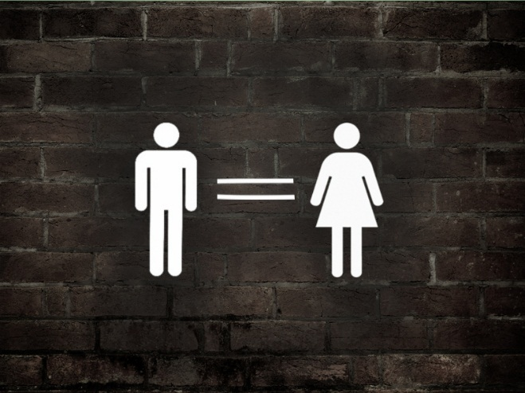
Now this is a troubling scripture for some because of the “wives submit to your husbands” stuff. And it's true that throughout history, this text has been used to justify abusive relationships. Some Christians today still use these verses to deny women real equality with men.

But let's take a hard look at what this text is actually saying. First, the reason it's so scary for some people is because of how we think of the words 'submit' and 'love'. 'Submit' is an authority word. It has a lot of power implications. If I'm submitting to you, I'm putting myself under you. So when it says "wives, submit to your husbands", we hear (and rightfully so) "wives put yourselves under your husband's power".

But then we get to "husbands love your wives" and we think, Well that's totally unfair. Because we think of love primarily as an emotion. We hear "husbands love your wives" and think it's saying "husbands feel affection for your wives and maybe buy her flowers or something".

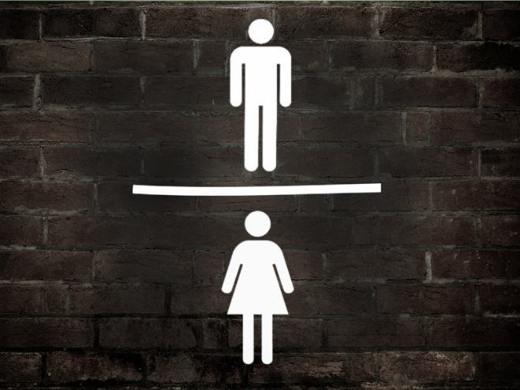
So we perceive the text as creating an imbalance: putting men over women But that's because in our culture today men and women are equal (or at least much more equal than any other time in history). So the instructions to wives, placing them below husbands, shocks our modern sensibilities.

In the ancient world, these words wouldn't have been a surprise to anyone. In the ancient world, men were the heads of the household. Women were essentially property. For the most part, women didn't have legal rights and were at the mercy of their husbands. So in that world, telling wives to submit to their husbands wasn't particularly noteworthy. Wives already did that.

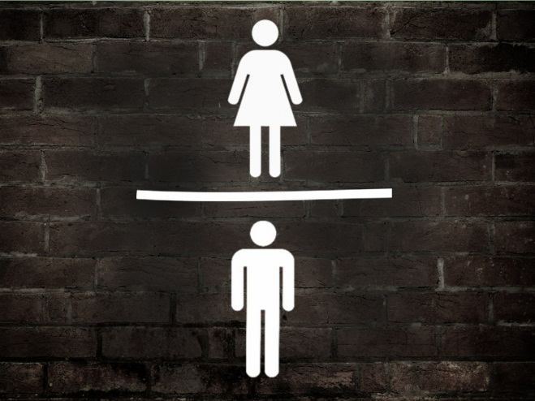
But then Ephesians tells these powerful men, these household heads that they're the head of their wives the way Jesus is the head of the Church. That means they don't get to lord their power over her. Instead, they are to love their wives "as Christ loved the Church", which means they take all their power, all their headship, and they give it up. Just like Jesus abandoned Heaven for us, became one of us and gave us his very life, so husbands are to give up everything for their wives.

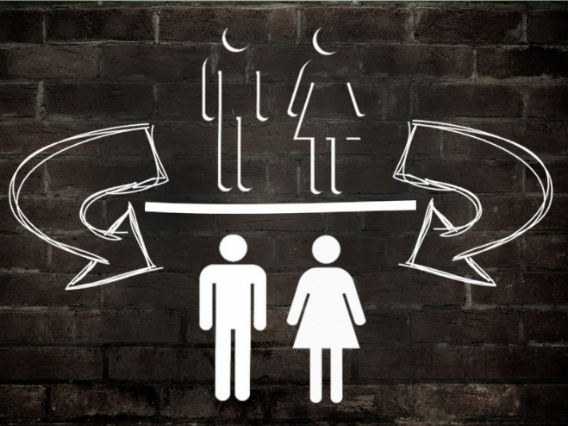
So according to Ephesians, in a Christian marriage, you have two people who are taking whatever power and authority they have and giving it to the other person. That's why the text started out with a much-ignored verse: Submit to one another out of reverence for Christ. -- Ephesians 5:21

If both partners are submitting to each other, you're on your way to a strong marriage. In a biblical marriage, each person looks at the other person as a chance to practice looking like Jesus. You behold your spouse and say, There is a person who is not me. I have the chance every day to practice giving myself up for them. Every day, this person is an opportunity for me to put their needs ahead of mine. Every day, I get to practice looking like Jesus to this person.

This is why the Church considers marriage a sacrament. The marriage relationship is the best crucible for making us look more like Jesus. Marriage can actually be a primary way we work out our salvation.

As people we're naturally selfish, self-centered people. We naturally want to look out for ourselves first, to do what makes us feel the most fulfilled. That's the root problem we call sin.

And that's what Jesus' death and resurrection overcome in us. In Jesus we find the model for overcoming our selfishness. Jesus shows us how to be selfless.

In Romans 5, Paul tells us, Our friendship with God was restored by the death of his Son while we were still his enemies. Romans 5:10 (NLT)

Jesus is the ultimate lover of the stranger because even when we were his enemies, he died for us. He gave himself over to us. For us. To rescue us from our sin. Through his death and resurrection, we are now free to become like him.

And that's how marriage transforms us: we get to practice overcoming our selfishness, our sin. The Marriage relationship brings out the very worst of who we are. No one will see you at your worst like your spouse will. And that can be scary. We don't like to be exposed like that. It makes us feel weak, powerless.

But that's good! Because the truth is we are weak and powerless. We need Jesus to rescue us and transform us. We need to be exposed. How are you ever going to grow if you keep all the bad stuff hidden from everyone? In a marriage relationship, that stuff gets dragged out into the light and you have to deal with it.

When we get into those places in a marriage when it gets hard, when the spouse seems like a stranger, even an enemy, we're tempted to quit. To throw in the towel. We think we've made a mistake, that because we don't seem compatible that this just isn't going to work.

We blame the other person - if they just weren't so _______, this could work. Do you really expect me to put up with someone who does __________?

We experience conflict and we think, We made a mistake. I need to get out, find someone who fits better with me.

But that's the wrong attitude to have. Because you'll never find the perfect match (they don't exist), and even if they did, you're always changing and so are they! Instead of looking for a perfect person you'll never have conflict with, expect the conflict as a normal, healthy part of marriage.

Rejoice that you've married the wrong person because you're the wrong person too. And that means both of you are a part of the other's ongoing salvation.

Instead of blaming the other person when you have problems, start with yourself. In a healthy, biblical marriage, both spouses assume that their own selfishness is the biggest problem in your marriage.

Let me say that again: If you want a healthy, growing relationship that is transforming both of you into the image of Jesus, you should assume that your own selfishness is the biggest problem in your marriage.

If Amanda and I are fighting about something, my natural tendency is to assume it's her problem. After all, have you met me? I'm awesome. Clearly I couldn't be wrong. (That’s our natural position, isn’t it? That’s what comes easiest to us, in moments of anger or confusion.)

But what if instead of assuming she's the problem, I start with myself? What if I spend some time in careful self-examination, discerning my motives and trying to figure out the role my own selfishness is playing in our conflict?

And what if when I find that selfishness, that insistence on getting my way, I give that up for her? Even better, what if I confess it to her and ask for her help in overcoming it?

[Interview with Mike and Julie Baker]

It's in the little moments that marriages are made or broken. It's those small, every day choices to love the stranger you married. To put their wants and needs before your own. These small daily decisions make us look more like Jesus.

A couple of provisos: first, this model we find in Ephesians 5 takes two spouses. If one spouse decides to make their own selfishness the main problem in the marriage and the other person just agrees - "Sure, I agree that it's all your fault" - then instead of a biblical, God-honoring marriage, you've got an abusive marriage.

In fact, if you've been elbowing your spouse and hoping THEY are listening, you need to stop. Because this isn't about them. It's about YOU. If your attitude is that YOU don't have any problems and THEY have a ton of work to do, you haven't been paying attention at all. You need to flip your paradigm. To submit yourself to your spouse, to love them like Jesus loved the Church.

All of this applies to those of us who aren’t married as well. A couple of thoughts for you: first, even if you're not married, you can still be transformed by relationships. This is the role godly friends play in your life. A mutually God-honoring friendship still gives you the opportunity to love and serve the way Jesus calls us to. It won't be as intense or consistent as a life-long marriage, but that's okay.

Second, if you're single and you desire marriage in the future, this should change how you look for a spouse. The search for compatibility should take a back seat to finding someone who makes you better and whom you make better. The best way to build this is on the back of a strong friendship that already has a lot of these qualities.

There's no such thing as a soulmate. God doesn't have a One picked out for you. So if you're trying to find that, quit it. Pour your time and energies into developing a strong community of friends, and if romance begins to grow out of that, all the better.

Finally, for those of you who live on the other side of marriage, especially if you're divorced, this doesn't change anything for you. You have some healing and growth to do. But so does everyone else. Whatever your relationships have looked like in the past, today is a new day and tomorrow's right around the corner. You can choose to move forward, to step into redemptive relationships that call you to be better, to look more like Jesus. This looks like friendships. Like community. It might look like marriage again.

And to all of you in marriages where things are tough, where you wake up next a person who seems like more and more of a stranger, if you're thinking, I married the wrong person!

You're right. And so did your spouse. And that's very, very good news. Because it means that both of you have room to grow, to look more like Jesus. There is someone better out there for you. And that person is the future person your spouse can become with your help.

Whatever the state of your marriage, the good news is that tomorrow can be better. God wants to heal you, to restore you, to make you holy. And God will use your spouse to do this. If you will open yourself to let that happen.

So will you commit to love that stranger? Will you choose to change, to work on those attitudes and behaviors your spouse finds hurtful or troublesome because you are submitting to them? Will you celebrate the conflict you experience because it is part of your journey to become more like Jesus?

Because that is the heart of the Gospel. Your spouse is your best opportunity to be transformed into the person God is calling you to be. Lean into that relationship.

Examine
- In the last week, how have I chosen to be selfish?
- In the last week, how have I chosen to look like Jesus?
- How has my selfishness been the source of conflict in my relationships this week?
- What relationships in my life help me to look more like Jesus?
- In the next week, how can I choose to lean into those relationships?
- In the next week, how can I choose to be selfless in my relationships?

