Experiences with the Revelation
Introduce yourself to some of the people around you. Share who you are and how long you’ve been a part of Beavercreek Nazarene. And something fun about yourself.

What experience do you have with the Revelation? How much time have you spent in the book and in what context(s)?

What do you hope to gain from this study?

Reading the Revelation

Principle: “The text can never mean what it never meant.”

A Brief History of Inspiration

Prophecy and Apocalypse and Political Cartoons
Read Revelation 1:1-3

Apokaluyij (apocalypsis) means “to unveil” or “an unveiling”

The $20 Definition of Apocalyptic Literature
“An apocalypse is a genre of revelatory literature with a narrative framework in which a revelation is mediated by an otherworldly being to a human recipient, disclosing a transcendent reality which is both temporal, insofar as it envisages eschatological salvation, and spatial, insofar as it involves another, supernatural world.”

The Power of Picture
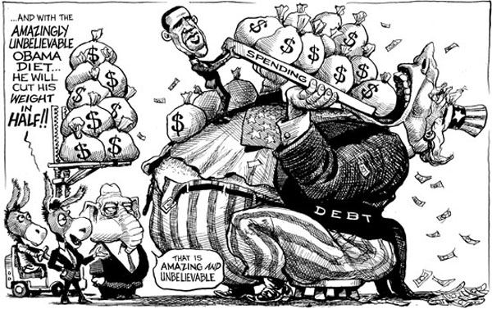

Consider the political cartoons. Why use them instead of writing an essay?

How do the images in political cartoons relate to reality? In other words: are they true?

God’s revelation of Jesus to John was not meant to be confusing or scary for believers. Rather, just as it claims, it contains a clear picture of who Jesus is that was readily understandable and relevant to the communities to whom it was written. Because it is prophecy, it was a timely message for the churches; because it is apocalypse, it presented an alternative picture of the churches’ reality.
The problem is not with the Revelation; it’s with us. We are the strangers to the text. I suggest that if we think like first century Jews, we too will understand the Revelation of Jesus to John.

Background, History and Culture
Date & Setting

Author

Audience

The World of Revelation
Israel/the Church

Sky/World

Old Testament Imagery

The Imperial Cult

Structure of Revelation
- Introduction (Chapter 1)
Perspective One: 7 Letters to 7 Churches
- Cosmic Jesus & the 7 Churches (Chapters 2-3)
Perspective Two: The View from the Top
- The Heavenly Throne Room: Who is worthy to open the seals? (Chapter 4-5)
- The Unsealed Scroll and the Sealed Children (Chapters 6-7)
- Announcements and Witnesses (Chapters 8-11)
Perspective Three: The Cosmic War
- The War in Heaven (Chapter 12)
- The Two Armies (Chapters 13-14:6)
- Seven Angels, Seven Plagues (Chapters 14:6-16)
- Two Women and a Wedding Feast (Chapters 17-20)
- The End (Chapters 21-22)

For Next Week
Read Revelation 1-3. See what you can learn about the various cities. What connections do you notice between Chapter 1 and each of the seven letters? What’s the most confusing? What’s clearest?

